**Experiment No. 1**

**Program Code** :-

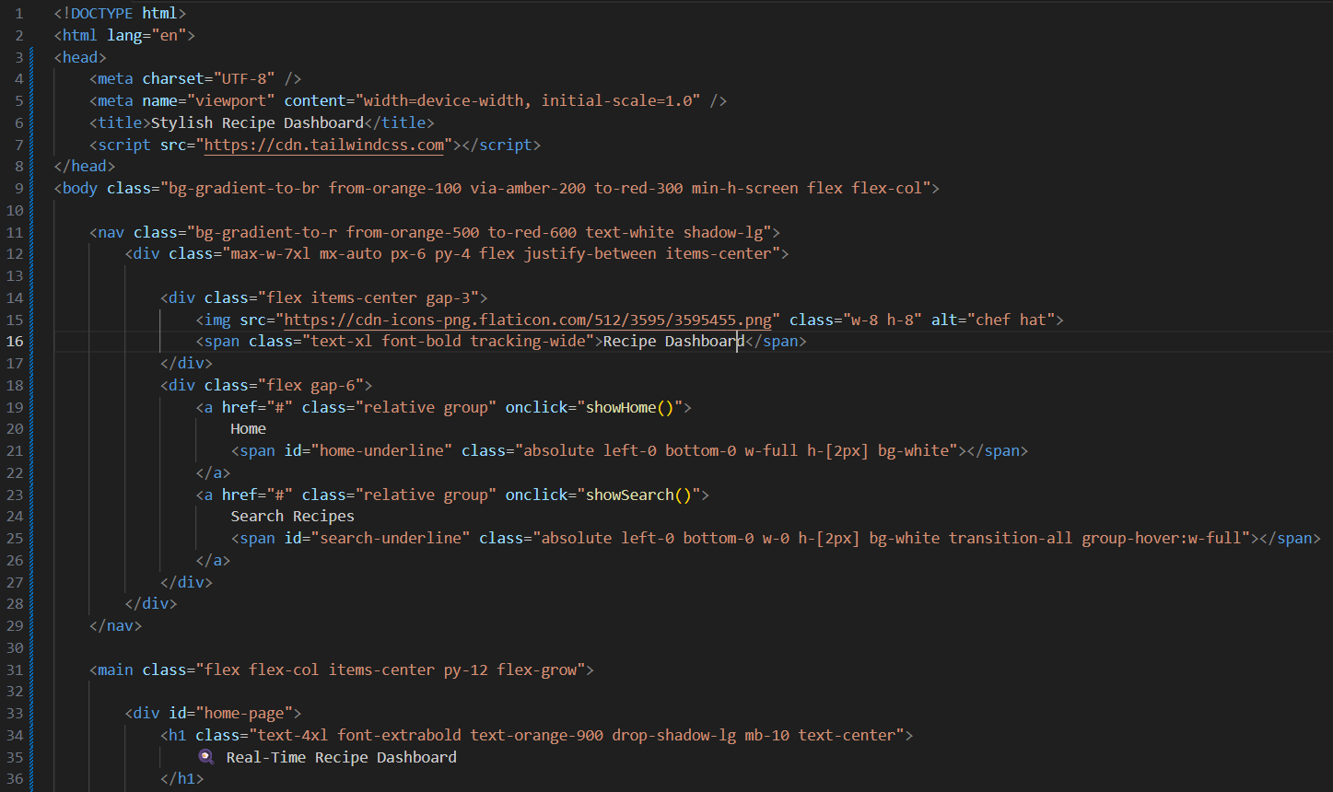

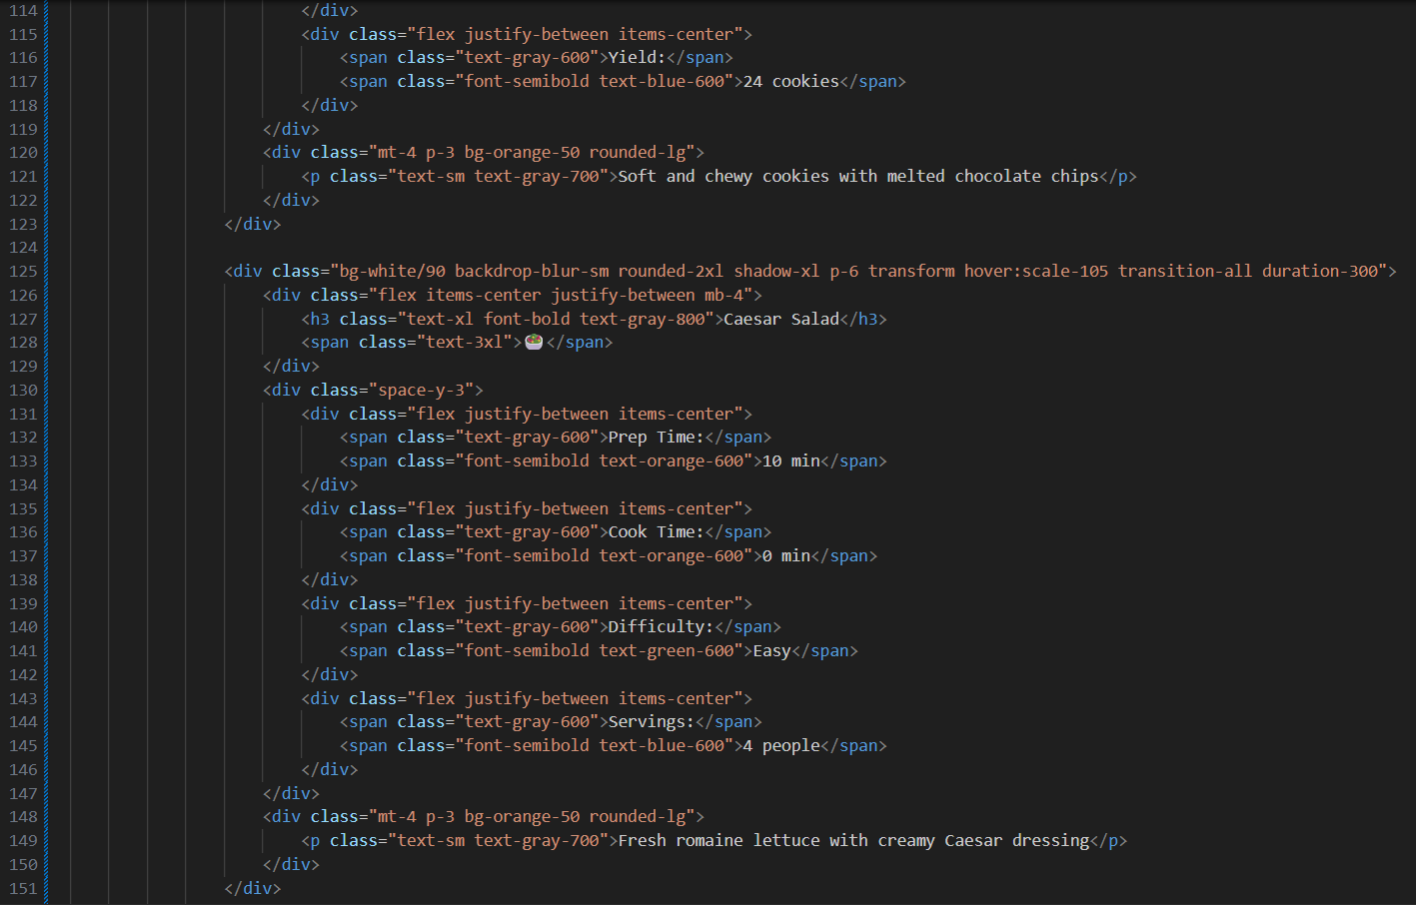

**Output :-**

* HomePage :-

* When Cursor hover on the Card ( Cursor is on the 2nd Card ) :-

* After clicking on “Search Recipes” Section :-

* Searching a specific Recipe :-

